**CIS 229 – Python Programming – Programming Project**

**Pica Centro**

Overview

In this assignment, you will be writing a Python script that implements the logical deduction game “Pica Centro”.

When completing this assignment, the student should demonstrate mastery of the following concepts:

* Variable Declarations
* Global Declarations (Variables and Constants)
* Function Syntax
* General Python Scripting Structure
* Boolean Logic
* Conditional Logic Control Structures
* Basic Python Console I/O
* Flagging
* Intuitive Interface Design
* Nested Control Structures
* Intermediate Conditional Logic Algorithm Design

Assignment

Pica Centro is an educational game used to teach children deductive reasoning at a young age. The game involves two players, a number selector and a guesser. The number selector selects a secret 3-digit number, writes it down, and hides it from the guesser. The guesser then proposes a 3-digit number to the number selector and is given a response as a count of ‘picas’ and ‘centro’s.

A ‘pica’ is given if one of the digits in the guesser’s number is correct, but in the wrong position. A ‘centro’ is given if one of the digits in the guesser’s number is correct and in the correct position. Any single digit in the guesser’s number can be a ‘pica’, ‘centro’, or neither, but cannot be both. Consider the following transcript of a sample game:

**The number selector secretly chooses the number: 1 5 8**

*The guesser guesses the number:  1 9 4*

**The number selector responds with:  PICA = 0, CENTRO = 1**

(this is because the digit 1 correct and also in the correct location within the guess)

*The guesser guesses the number: 9 8 6*

**The number selector responds with: PICA = 1, CENTRO = 0**

(this is because the digit 8 is correct, but was placed in the wrong position within the guess)

*The guesser guesses the number: 1 7 8*

**The number selector responds with: PICA = 0, CENTRO = 2**

(this is because the digit 1 is correct and in the correct position and the digit 8 is correct and in the correct position; the digit 7 is not present in the secret number)

*The guesser guesses the number: 1 5 8*

**The number selector responds with: PICA = 0, CENTRO = 3**

(this is because all of the digits are correct and all in the correct positions)

THE GUESSER WINS

Assignment

In this assignment, you will be writing a Python script that implements a simple version of this game. The program should begin by allowing a user to enter a secret number (one digit at a time). The digits are then stored and the screen is cleared to hide the secret number from the guesser. Recall the function definition used to clear the console in a Python script:

def clearScreen():

 clear = ‘ \n’ * 100

 print(clear)

The program will then give the guesser ten guesses to try and figure out the number. After each guess, the program should display a neat table clearly showing the guess presented and the number of picas and centros for that guess. If the guesser is able to deduce the original number, the program should display a victory message and end. If the guesser exhausts all ten guesses without getting the secret number, the program should display a defeat message and also end.

When writing this program, be sure to demonstrate the concepts of global variables, functions, conditional logic, and formatted IO in Python. Adhere to all established Python programming conventions and make your solution as intuitive and clean as possible. Also keep in mind that this program can be written without the use of any repetition structures (no loops are required). However, if you choose to use loops to optimize the logic of your program, you are welcome to do so.

Sample Trial #1 – You WIN

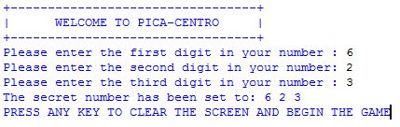

<THE SCREEN CLEARS>

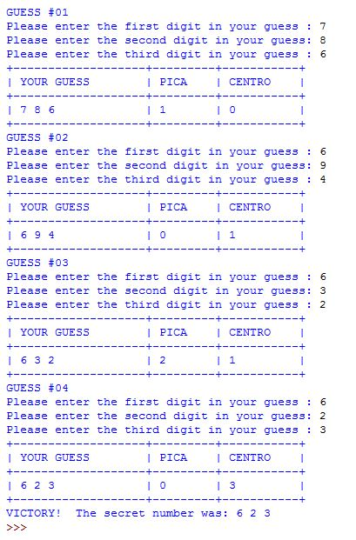

Sample Trial #2 – You LOSE

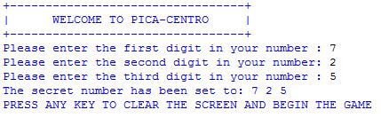

<THE SCREEN CLEARS>

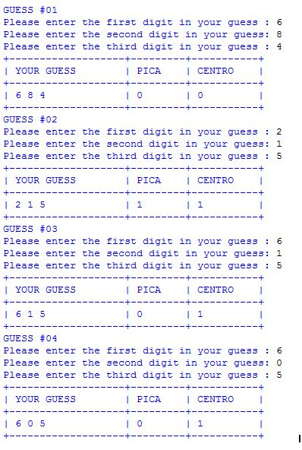

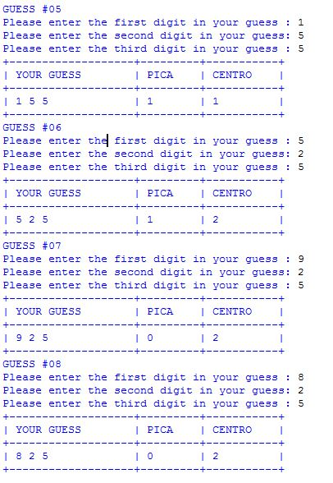

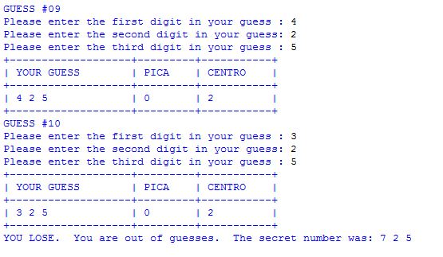

Assessment

This assignment will be assessed based on the provided grading rubric.